PROJECT REPORT
ON
Academic Task Management System(SmartTrack) (BCA-605)



Submitted By: Submitted To:
Shimali Dr. Sanjeev Puri
1323044 Professor
Section: - 6th P1 [G-1] MMICT&BM

M.M. Institute of Computer Technology & Business Management Maharishi Markendeshwar (Deemed to be University), Mullana–Ambala
(Established under Section3 of the UGC Act, 1956) (Accredited by NAAC with Grade ‘A++’)

DECLARATION

I hereby declare that the work which is being presented in this report entitled “ACADEMIC TASK MANAGEMENT SYSTEM”, in the partial fulfillment of the requirement for the award of the degree of “BACHELOR OF COMPUTER APPLICATION” submitted at M.M Institute of Computer Technology & Business Management, MMICT&BM.

MAHARISHI MARKENDESHWAR (Deemed to be University), Mullana, Ambala is an authentic work done by me and my partner during a period from Jan 2026 to Apr 2026, under the provision of Dr. Sanjeev Puri, Professor.

Submitted By:
Shimali (1323044)

This is to certify that the above statement made by the above candidates is correct to the best of my knowledge.
Supervisor:
Dr. Sanjeev Puri Professor
MMICT&BM

ACKNOWLEDGEMENT

I am pleased to acknowledge Dr. Sanjeev Puri, Professor at Maharishi, Markandeshwar Institute Of Computer Technology & Business Management (MMICT&BM), for his invaluable guidance, continuous support, and constant encouragement throughout the development of this project. His Knowledge, insightful suggestions, and patient understanding helped me at every stage of the project and played a significant role in shaping this work.

I am extremely grateful for the time and effort he invested in guiding me, clarifying my doubts, and motivating me to perform better. His constructive feedback and expert advice not only improved the quality of my project but also enhanced my understanding of the subject.

Without his proper guidance, encouragement, and support, this project would not have been successfully completed. I sincerely thank him for being a constant source of inspiration and for helping me achieve this milestone.

Signature
Dr. Sanjeev Puri (Professor) MMICT&BM,
MM (Deemed to Be University)

INDEX

Sno. | Title | Page no.
1. | Introduction:  - Introduction  - Problem definition  - Project objectives  - Project purpose  - Project features | 6
2. | Literature Survey:  - Web Based Productivity System  - Existing System  - Proposed System | 9
3. | Requirement Analysis:  - Functional Requirements  - Non-Functional Requirements  - Hardware Requirements  - Software Requirements | 11
4. | Feasibility Study:  - Overview  - Technical Feasibility  - Operational Feasibility  - Economic Feasibility  - Legal and Ethical Feasibility  - Social Feasibility | 13
5. | Project system architecture:  Authentication Module  Task Management Module  Notes and File Management Module  Study Planner Module  Quick Links Module  User Interface and Navigation Module | 15
6. | Design:  - Design Goals  - System Architecture  - Use Case Diagram | 18
7. | Implementation:  - Dataset  - Data Preprocessing  - Implementation | 22
8. | Testing:  8 8.1Types of Tests 7 8.1.1-unit testing  8.1.2-intergration testing 8.1.3-validation testing 8.1.4-system testing | 26
9. | Tools Used  9.1 Frontend Tools  9.2 Backend Tools | 28
10. | Primary And Secondary Domain Constraints  10.1 Primary Domain  10.2 Secondary Domain | 30
11. | Snapshots | 32
12. | Future Scope of The Project | 37
13. | Key Insights | 38
14. | Conclusion | 39
15. | References | 40

INTRODUCTION

Introduction

SmartTrack Dashboard is an integrated web-based platform designed to enhance student productivity and academic organization. In the modern educational environment, students often rely on multiple disconnected tools to manage tasks, schedules, notes, and study plans. This fragmentation leads to inefficiency, loss of focus, and difficulty maintaining consistency across devices. SmartTrack Dashboard addresses these challenges by centralizing essential academic functions into a single, intuitive, and secure portal.

Developed using the MERN stack (MongoDB, Express.js, React, and Node.js), the system delivers a seamless user experience powered by modern web technologies. It allows students to manage their daily to-do lists, plan study sessions, record notes, track academic calendars, and access institutional resources from one unified dashboard. With responsive design principles, SmartTrack ensures accessibility across desktops, tablets, and mobile devices.

The project emphasizes secure authentication using JSON Web Tokens (JWT), efficient data handling through Mongoose, and a clean, responsive user interface implemented in React with Bootstrap. Persistent dark and light themes enhance usability, while validation and error-handling mechanisms ensure reliability. Each component, from user registration to file management, communicates through RESTful APIs, maintaining modularity and scalability for future expansion.

By promoting focused study habits and efficient time management, SmartTrack Dashboard demonstrates the practical capability of a full-stack web application in solving real-world student productivity issues. The platform showcases modern software development techniques, including RESTful system design, responsive UI/UX, and secure backend logic, making it both a learning tool and a potential deployable solution for institutions.

The development of SmartTrack Dashboard focuses not only on functionality but also on scalability, performance, and security. It integrates advanced backend logic with user-friendly frontend design, ensuring smooth interaction and efficient data flow. The project follows software engineering best practices such as modular coding, API-driven communication, and responsive layout implementation. By combining academic-oriented utilities like a study planner and calendar scheduler with modern web
technologies, SmartTrack serves as a comprehensive solution for students seeking an all-in-one digital

workspace. This platform also lays a foundation for future enhancements such as data analytics, AI-assisted study recommendations, and peer collaboration features.

Problem definition

In today’s academic environment, students often rely on multiple unconnected applications and manual planners to manage their daily academic activities, such as maintaining to-do lists, scheduling study sessions, storing notes, and accessing learning resources. This fragmented approach leads to inefficiency, data loss, and distraction, affecting overall productivity and time management.

The objective of the SmartTrack Dashboard is to create a unified platform that integrates essential academic tools within a single web application. It focuses on solving the issues of disorganization, uneven workload distribution, and lack of centralized access. The system aims to enable students to efficiently plan, track, and manage their academic responsibilities while maintaining data privacy and accessibility across devices. Through real-time synchronization and responsive design, the project seeks to simplify student workflow and enhance learning effectiveness.

Project objectives

The objectives of the SmartTrack Dashboard project focus on improving student productivity, promoting better academic organization, and providing a centralized digital workspace for effective study management. The system integrates modern web technologies to enhance efficiency, security, and accessibility while ensuring a user-friendly experience across devices.

Key Objectives of SmartTrack Dashboard Project:
    - Centralized Productivity Platform: Develop a unified portal that combines task management, note-taking, calendar scheduling, and study planning to reduce the need for multiple applications.
    - ·Efficient Task Organization: Enable students to create, update, and track daily academic activities with reminders and visual progress indicators.
    - Secure Authentication: Implement JWT-based login and encrypted passwords using bcrypt to ensure data privacy and authorized access.

    - Responsive and Accessible Design: Build a modern, adaptive interface using React and Bootstrap for consistent user experience on desktops, tablets, and mobile devices.
    - Data Management and File Handling: Allow students to upload, organize, and manage digital resources efficiently through database-linked file management with secured storage.
    - Study Planner Automation: Introduce algorithm-based planning to allocate study hours by subject difficulty and exam schedule, helping students manage time effectively.
    - Future Scalability: Design the system with modular APIs and extendable architecture to support additional features such as collaboration tools, performance analytics, and AI-based study support.

Project Purpose
The purpose of the SmartTrack Dashboard project is to design and develop an integrated platform that streamlines academic planning, task management, and resource organization for students. With the increasing complexity of academic workloads and digital resources, there is a growing need for a centralized system that assists students in efficiently managing their study activities.

To achieve this, the project implements a web-based solution using the MERN stack that allows users to maintain to-do lists, schedule study sessions, record notes, and access essential university resources from one location. The platform focuses on productivity enhancement through effective data organization and responsive interface design. The aim is to simplify the learning process, reduce time wasted between multiple tools, and improve academic concentration. As education increasingly shifts toward digital environments, SmartTrack Dashboard serves as a technological approach to modern learning demands by promoting structured, self-managed, and goal-oriented study habits.

LITERATURE SURVEY

Web-Based Productivity Systems
Web-based productivity systems are online applications designed to assist users in managing their daily activities, schedules, and resources more effectively. These systems integrate multiple functionalities such as task tracking, reminders, note management, and collaborative tools within a single accessible interface. The goal of such applications is to enhance time management, reduce workload complexity, and improve performance through digital automation and synchronization.

In recent years, technologies like React, Node.js, and MongoDB have allowed developers to create dynamic, scalable, and responsive web applications that maintain a clean separation between the client and server sides. These systems use secure authentication methods and real-time data processing to ensure reliability and privacy for end users. Web-based productivity platforms are increasingly used in the educational domain, enabling students to organize study tasks, manage notes, and schedule calendars efficiently. The principles behind these systems lay the foundation for modern student dashboards like SmartTrack, which combine design simplicity with advanced backend operations to enhance user experience and academic management.

Existing system

In the current academic environment, students often rely on multiple separate applications to handle their daily academic requirements. Task management apps, note-taking tools, calendars, and study planners operate independently, causing data fragmentation and inefficiency. Traditional paper-based planners or basic mobile task apps lack real-time synchronization, centralized access, and data security. Moreover, these tools do not provide integrated support for resource management or personalized study planning.

Existing systems also struggle to maintain consistent user experience across devices, and most lack intuitive dashboards that summarize all academic activities in one place. Consequently, students face challenges in organizing their workloads, managing time effectively, and keeping track of academic progress. This absence of a unified digital platform motivated the development of a comprehensive system like SmartTrack Dashboard.

Proposed system

The proposed system, SmartTrack Dashboard, provides a unified platform that integrates task management, note-taking, calendar scheduling, and study planning for students. It is developed using the MERN stack to ensure high performance, scalability, and secure data handling. The system allows users to register securely, manage academic activities, and access resources through an interactive dashboard. With features like JWT authentication, responsive design, and a study planner algorithm, SmartTrack simplifies daily academic organization while promoting effective time management and digital productivity.

REQUIREMENT ANALYSIS

Functional requirement

The functional requirements define the specific behavior and operations that the SmartTrack Dashboard system must perform. They determine how the system interacts with users and handles various academic and productivity tasks efficiently.
    - The system should allow users to register, log in, and log out securely using JWT authentication.
    - It should enable users to create, view, edit, and delete tasks, notes, and study plans.
    - The system must provide a calendar interface to schedule academic events and set reminders.
    - It should allow users to upload, download, and manage files within organized folders.
    - The system must store and retrieve all data from the MongoDB database through RESTful APIs.
    - It should provide light and dark mode options with persistent user preferences.
    - The system should send toast notifications for user actions such as login success, errors, or updates.
    - It must ensure only authenticated users can access protected routes and features.

Nonfunctional system

Non-functional requirements describe the quality and performance standards that the SmartTrack Dashboard must meet. These ensure system security, usability, and scalability.
    - Reliability: The system must maintain data integrity even during unexpected shutdowns or network failures.
    - Performance: It should deliver fast responses and smooth navigation with minimal load time.
    - Scalability: The platform should support more users and data as the system expands.
    - Usability: All modules should have a clear, user-friendly interface accessible across devices.
    - Security: Passwords should be encrypted, and access should be restricted to authorized users.
    - Portability: The web app should run on different operating systems and devices through browsers.
    - Maintainability: The code should be modular to allow easy updates and integration of new features.

Hardware requirements
Hardware refers to the physical components necessary for developing and running the SmartTrack Dashboard system.

    - System: Any personal computer or laptop
    - Processor: Intel i3 or higher (2.0 GHz or above)
    - Hard Disk: Minimum 50 GB free space
    - RAM: 8 GB (recommended)
    - Display: 1280×720 resolution or higher

Software requirements
Software requirements define the tools, platforms, and technologies used to design, develop, and deploy the system.
    - Operating System: Windows 10/11, macOS, or Linux
    - Frontend: React 19, Vite, Bootstrap, React Router
    - Backend: Node.js and Express.js
    - Database: MongoDB (local)
    - Programming Language: JavaScript (ES6)
    - Authentication: JWT, js
    - Tools & IDE: Visual Studio Code, Postman, MongoDB Shell, Compass.
    - Server Environment: Node.js runtime, npm dependencies.

FEASIBILITY STUDY

Overview
The SmartTrack Dashboard project aims to develop an integrated, web-based platform that centralizes academic task management, calendar scheduling, note-taking, and study planning for students. It strives to enhance student productivity by providing a unified, secure, and responsive system accessible across multiple devices.

Technical feasibility
Tools & Technologies: MERN stack (MongoDB, Express, React, Node.js), JWT, bcryptjs, Bootstrap, Vite.
    - Analyze the technical requirements of building scalable RESTful APIs, secure authentication, and responsive frontend interfaces.
    - Ensure compatibility with local or cloud-based MongoDB deployments and support for file uploads/storage.
    - Evaluate the use of middleware like Multer for file handling and React libraries for UI components.
    - Consider system scalability to handle increasing users and data volume efficiently.

Challenges:
      - Maintaining data consistency and synchronization between frontend and backend.

      - Safeguarding user data with robust security practices, including HTTPS and token expiry.

Operational feasibility

    - User Base: University students, educators, and institutional administrators.
    - Ease of Use: Designed with intuitive UI elements, dark mode, and toast notifications for user feedback.
    - Deployment: Can be deployed locally or on cloud platforms supporting Node.js; supports cross-device access through browsers.

Economic feasibility

    - Development Costs: Low to moderate, leveraging open-source tools and existing resources.
    - Tools: Entirely based on free, open-source frameworks and libraries.
    - Return on Investment: High potential by improving student productivity, reducing administrative workload, and enabling scalable adoption across institutions.

Legal and Ethical feasibility
    - Ensure compliance with data privacy standards applicable to educational institutions.

    - Implement secure password management and encrypted data storage to protect user information.
    - Maintain transparency regarding data usage and provide user controls for privacy settings.

    - Avoid unauthorized data sharing or tracking that could violate user rights.

Social Feasibility

    - Assess user acceptance among students and faculty through usability testing and feedback.
    - Provide training materials or guides to ensure effective adoption of the system.
    - Promote the platform as a productivity aid that supports academic success rather than a surveillance tool.
    - Consider the impact on existing institutional workflows and encourage integration rather than disruption.

PROJECT SYSTEM ARCHITECTURE

The SmartTrack Dashboard is designed using a three-tier architecture, which separates the system into three main layers: Frontend (Client Side), Backend (Server Side), and Database Layer. This architecture ensures better scalability, security, and maintainability of the application. The frontend communicates with the backend through RESTful APIs, and the backend interacts with the database to store and retrieve data.

Authentication Module

The Authentication Module is responsible for managing user identity and securing access to the application. It ensures that only registered users can access the system features.

Working:

When a user registers, their details are validated and the password is encrypted using hashing techniques. During login, the system verifies credentials and generates a JWT token. This token is used to authenticate further requests.

Sub-modules / Tasks:

User Registration (store email & hashed password)

User Login (verify credentials & generate token)

Profile Update (modify user details)

JWT Authentication Middleware (protect routes)

Task Management Module (To-Do + Calendar)
This module helps users manage their daily tasks efficiently and track deadlines using a calendar interface.
Working:
- Users can create tasks with due dates and priorities. These tasks are stored in the database and can be retrieved or modified anytime. The calendar visually displays tasks based on selected dates.
Sub-modules / Tasks:
- Task Creation (title, date, priority)
- Task Retrieval (all tasks / date-wise tasks)
- Task Update (mark complete/incomplete)
- Task Deletion
- Calendar Integration (visual task tracking)
  - Notes & File Management Module

This module allows users to store and organize their study materials in a structured way using folders and files.

Working:

Users can create folders and upload files into them. Files are stored on the server, and their details are saved in the database. The system supports nested folders and secure file access.

Sub-modules / Tasks:

Folder Creation (parent-child structure)

File Upload (store in server directory)

File Retrieval (view/download files)

Recursive Deletion (delete folder with contents)

Access Control (user-specific files)

Study Planner Module

This is the core intelligent module of the system, designed to help students prepare for exams effectively.

Working:

The user enters exam date, subjects, difficulty levels, and study hours. The system calculates the number of available days and distributes study time based on subject priority. Weak subjects are given more time.

Sub-modules / Tasks:

Input Collection (subjects, hours, exam date)

Weight Assignment (weak = high priority)

Time Distribution Algorithm

Plan Generation (daily schedule)

Output Display (structured study plan)

Quick Links Module

This module provides shortcuts to commonly used platforms, improving productivity.

Working:

Users can directly access external resources without leaving the dashboard.

Sub-modules / Tasks:

External Links Integration

Open links in new tab

UI interaction with hover effects

User Interface & Navigation Module

This module ensures smooth interaction and navigation across the application.

Working:

It manages routing, themes, and layout responsiveness. It also ensures that only authenticated users can access protected pages.

Sub-modules / Tasks:

Navbar & Routing

Theme Toggle (Light/Dark mode)

Protected Routes

Responsive Design

DESIGN

Design goals

Design goals for the SmartTrack Dashboard focus on maximizing usability, maintainability, and scalability for student productivity, while ensuring secure data management and a seamless user experience. The platform is structured to integrate multiple academic tools, such as to-do lists, calendar, notes, study planning, and quick resource access, into a unified web dashboard. Major design considerations include customizing responsive layouts, persistent theme support, and robust authentication.

Key Design Goals for Fake News Detection

Usability :
Strive for an intuitive, simple interface allowing quick navigation between modules like To-Do, Calendar, Notes, Study Planner, and resource links.

Security and Authorization :
Ensure user accounts and private data are securely handled using encrypted passwords (bcrypt) and JWT-based authentication for access control.

Scalability :
Architect code and APIs to support multiple users, growing datasets, and quick addition of new modules or features.

Performance :
Optimize load times through Vite-powered frontend and efficient RESTful APIs serving frontend components and database queries.

Maintainability :
Use modular React components and backend models for easy code updates, bug fixes, and future feature expansion.

Responsiveness :
Adapt layouts to different devices, maintaining accessibility and clarity for both desktop and mobile users.

File Management :
Provide organized file uploads/downloads, with metadata in MongoDB and binaries stored securely on disk.

The main benefits of the system are:
    - Affordable and open-source for deployment.
    - Integrated student resource management.
    - Minimizes the time required for academic task organization.
    - User-friendly, easily grasped interface design.
    - Simplifies handling large volumes of academic data.

6.2 System architecture

The platform follows a standard client-server architecture using the MERN technology stack:
    - Frontend (React + Vite):
Delivers user interfaces for dashboard, to-do list, calendar, notes, study planner, resource links, profile, login/signup screens. Uses React Router for navigation and Bootstrap/custom CSS for visual design
    - Backend (Node.js + Express):
Handles RESTful API requests for all modules (tasks, notes, folders/files, study plans, authentication). Manages data logic, validation, security, error handling, and communicates with MongoDB.

Database (MongoDB via Mongoose):
Stores user, task, folder, file, and study plan data as collections. Only metadata for files is stored in DB, while actual uploads are managed on disk.

Authentication and Security:
JWT tokens control user sessions. bcrypt is used for password hashing. Protected routes ensure authorized access.

User Input
API
Request
Backend Processing
Dashboard Output

Fig 6.1 Data Flow Diagram


Database
MongoDB
Rest API
Node.js / Express Server
File Storage
Disk Uploads
User Interface React Dashboard

Fig 6.2 System Architecture

6.3 Use case diagram

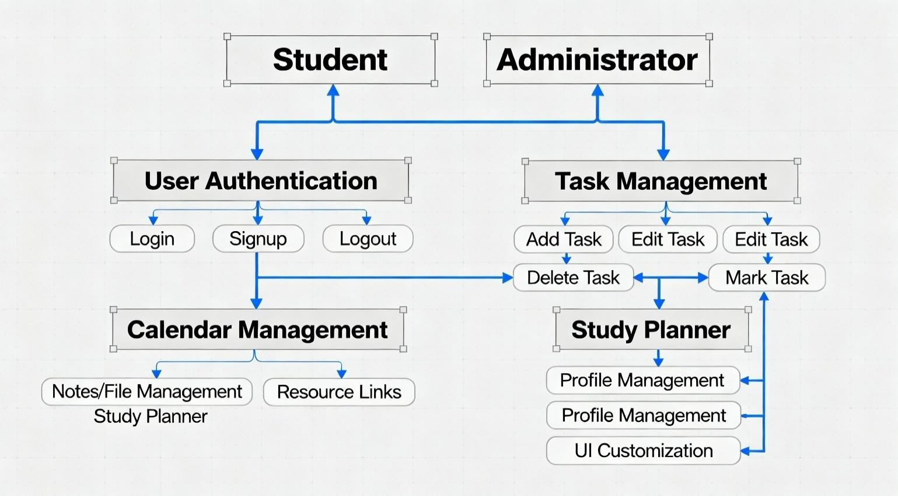

Fig 6.3 use case diagram

IMPLEMENTATION

Dataset
The dataset in SmartTrack Dashboard consists of user-generated and system-generated academic productivity data stored in MongoDB collections. It includes information relevant to tasks, calendar events, notes, study plans, user profiles, and resource links. Each data entry corresponds to a unique user and contains metadata such as timestamps, priority, status, and associations to other entities like folders or subjects.
The dataset comprises the following components:
    - Users: Information such as username, email, hashed password, profile details.
    - Tasks: Task title, description, category, due date, priority, completion status.
    - Calendar Events: Event title, description, start and end date/time, reminder settings.
    - Notes and Files: Note contents, filenames, file paths, folder hierarchy.
    - Study Plans: Subjects, assigned study hours, difficulty levels, daily schedules.

Data processing

Data collected from user inputs and backend processes requires validation, consistency checks, and formatting before storage or display. The following Data Processing steps ensure data quality and efficient system operation:

Data Collection:
  - Data is gathered in real-time through frontend forms and API calls from authenticated users.
  - File uploads and calendar inputs form part of the dataset simultaneously.

Data Validation and Cleaning:
  - Input fields are validated client-side (React) and server-side (Express) for completeness and correctness.
  - Duplicate entries in tasks or notes are minimized through uniqueness constraints or checks.
  - Invalid or harmful inputs (e.g., XSS scripts) are sanitized before processing.

Data Integration:
  - Data from various modules (tasks, notes, calendar) are linked via references such as user IDs and folder IDs to maintain relational integrity.

  - Consistency of date/time formats and time zones is ensured.

Data Transformation:
  - Dates and timestamps are normalized to a standard format (ISO 8601) for uniform storage.
  - Task priorities and statuses are encoded with predefined enum values.
  - Data rendering formats (e.g., markdown for notes) are processed before display.

Data Storage:
  - MongoDB is used to efficiently store and index structured data, supporting quick retrieval and updates.
  - Binary file data is stored on disk, with metadata and links saved in document collections.

Data Retrieval and Synchronization:
  - Frontend fetches updated data via REST APIs with real-time update considerations (optional enhancements).
  - Local caching and session management improve responsiveness in the user interface.

Data Backup and Security:
  - Regular backups of MongoDB enable data recovery.
  - Sensitive data like passwords use bcrypt hashing and JWT-secured sessions to protect data privacy.

Data Visualization:
  - Interactive components such as calendar views and progress bars utilize processed data to improve user productivity.
  - Dashboard elements visually summarize task statuses, study hours distribution, and
  - upcoming events.

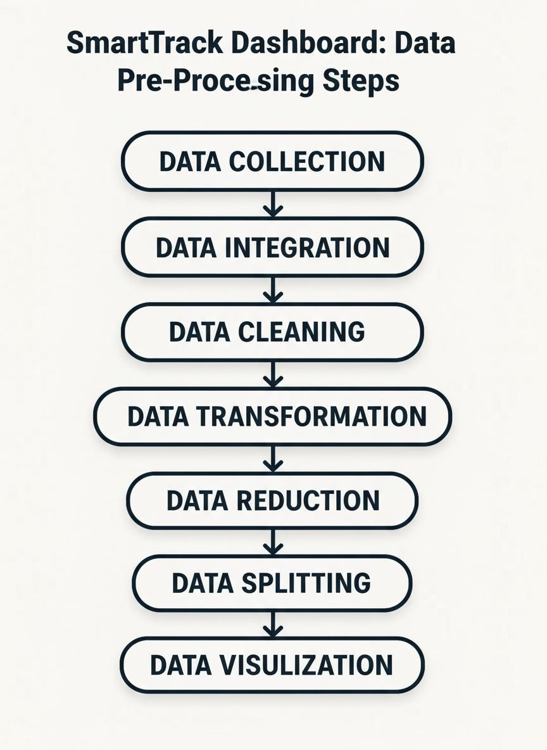

Fig 7.2 Data Pre-Processing steps
  - Implementation

The implementation phase involves the actual coding, development, and integration of various features for the SmartTrack Dashboard platform using the MERN stack.

Technologies Used
    - Frontend: React 19 with Vite for fast development and Bootstrap for responsive UI.
    - Backend: Node.js with Express framework to build RESTful APIs.
    - Database: MongoDB managed with Mongoose ORM for schema-based data modeling.
    - Authentication: JWT tokens and bcryptjs for secure, stateless login and password hashing.
    - File Handling: Multer middleware for handling user file uploads with secure storage on disk.

Core Modules Implemented
    - User Authentication: Signup, login, and JWT-based session management with token expiration and protected routes.
    - Task Management Module: CRUD operation on to-do lists with task priority and completion tracking.

    - Calendar Module: Interactive scheduling and task assignment with backend persistence.
    - Notes and File Management: Creating, editing, uploading, downloading, deleting notes and files within user-defined folders.
    - Study Planner: Algorithm for allocating study hours based on subject difficulty and upcoming exams, saved to the database.
    - Quick Links: Predefined university resource shortcuts accessible via dashboard cards.
    - UI Features: Responsive layouts, dark and light modes with persistent user preference, and toast notifications for user feedback.

Data Flow and Integration
    - Frontend components communicate with backend APIs for data CRUD operations and authentication flows.
    - All data updates are validated both on client and server sides to maintain consistency and security.
    - Real-time UI state updates are performed by React using API responses, ensuring a smooth user experience.

Challenges and Solutions
    - Ensuring secure file uploads while maintaining efficient storage by saving metadata in the database and binaries on disk.
    - Implementing robust validation on forms to prevent invalid or malicious inputs.
    - Achieving responsive design for a consistent experience across desktop and mobile devices.

Development Environment
    - Visual Studio Code was used as the primary IDE.
    - Local MongoDB and Node.js servers powered backend development, with frontend served via Vite.dev server.

TESTING
Testing is the process of identifying defects or errors in a software product. It provides a means to evaluate the quality of individual components, integrated modules, and the complete system. Various types of testing serve different purposes to ensure the software meets the desired specifications and functions reliably.

Types of Tests

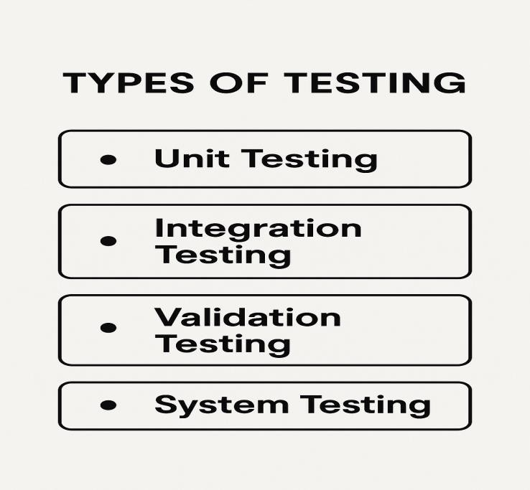

Fig 8.1 Types of Tests
8.1.1 Unit testing

Unit testing involves designing and performing tests on individual units or components of the application to verify that the internal logic operates as expected. For SmartTrack Dashboard, unit tests verify the behavior of core modules such as task management, user authentication, and calendar event functions. Unit tests are executed during development to catch errors early, reduce bugs, and confirm that each function or component produces the correct output for given inputs.

Integration testing

Integration testing assesses the interaction between multiple components or modules combined as a group. This testing validates that integrated parts of SmartTrack Dashboard—such as backend APIs interacting with the MongoDB database or frontend requests received by the Express server—work together seamlessly. It detects defects caused by interface mismatches, data flow issues, or functional integration flaws.

Validation testing
Validation testing is performed to confirm that the product meets the user and business requirements. Early prototype testing of the SmartTrack Dashboard user interface and functionality helps identify design issues and ensures the system aligns with academic productivity needs. Swift resolution of design or functional problems during validation prevents delays and cost overruns later in development..

System testing
System testing evaluates the entire integrated system to ensure that it complies with specified requirements. After successful unit and integration testing of all SmartTrack Dashboard modules, system testing verifies the overall functionality—including authentication, task scheduling, notes management, study planning, and file handling—in a real or simulated environment. This testing encompasses functional and non-functional aspects such as performance, security, usability, and reliability.

TOOLS USED
The development of the SmartTrack Dashboard involves various modern tools and technologies for both frontend and backend. These tools help in building a responsive user interface, handling server-side logic, ensuring security, and managing data efficiently.

9.1 Frontend Tools :- The frontend of the application is developed using modern JavaScript libraries and frameworks that provide a dynamic and interactive user experience.

  - React:- React is used to build the user interface of the application using a component-based architecture. It allows the creation of reusable components such as Navbar, Dashboard, and Task Manager. React also enables efficient rendering using the virtual DOM.
Key Uses:
- Creating UI components
- Managing state using hooks (useState, useEffect)
- Rendering dynamic data

  - Vite :- Vite is used as a fast development and build tool. It provides a lightning-fast development server and supports hot module replacement (HMR), which updates changes instantly without reloading the page.
Key Uses:
- Fast project setup
- Instant reload during development
- Optimized production build

  - React Router :- React Router is used for navigation between different pages of the application without refreshing the browser.
Key Uses:
- Page routing (Login, Dashboard, Notes, etc.)
- Protected routes for authenticated users

  - Bootstrap:- Bootstrap is used to design responsive layouts and improve the overall look of the application.
Key Uses:
- Grid system for layout
- Pre-designed UI components
- Responsive design for mobile and desktop

  - React Toastify :- React Toastify is used to display notifications for user actions such as success messages, errors, and alerts.
Key Uses:
- Toast notifications
- User feedback

9.2 Backend Tools:- The backend is responsible for handling server logic, API requests, authentication, and database communication.

- Node.js:- Node.js is used as the server-side runtime environment to execute JavaScript code outside the browser.
Key Uses:
- Running backend server
- Handling asynchronous operations

- Express.js:- Express.js is used to build RESTful APIs and manage server-side routing.
Key Uses:
- Creating API endpoints
- Handling HTTP requests (GET, POST, PUT, DELETE)

- MongoDB:- MongoDB is a NoSQL database used to store application data in a flexible JSON-like format.
Key Uses:
- Storing user data, tasks, files, and study plans
- Fast data retrieval

- Mongoose:- Mongoose is used to define schemas and interact with MongoDB in a structured way.
Key Uses:
- Schema definition
- Data validation
- Query handling

- bcryptjs:- bcryptjs is used to encrypt user passwords before storing them in the database.
Key Uses:
- Password hashing
- Secure authentication

PRIMARY & SECONDARY DOMAIN CONSTRAINTS

The SmartTrack Dashboard belongs to the domain of student productivity and academic management systems. While designing such systems, certain constraints must be considered to ensure proper functionality, performance, and user satisfaction. These constraints are broadly divided into Primary Domain Constraints and Secondary Domain Constraints.

10.1 Primary Domain (Core Domain)
The primary domain of this project is Education and Student Productivity Management. The system is designed to help students manage their academic tasks, study schedules, notes, and deadlines efficiently.
Since the application directly deals with students’ academic activities, it must ensure accuracy, reliability, and ease of use. Any error in scheduling or task management may affect the student’s performance. Therefore, the system must be designed carefully to meet academic requirements.

Constraints:
  - Accurate Time Management:
The system must correctly calculate dates, deadlines, and study schedules. Incorrect calculations may lead to poor planning.
  - User Data Security:
Since the system stores personal data (email, password), it must ensure secure authentication using encryption and tokens.
  - Data Isolation:
Each user should only access their own data (tasks, notes, files). Proper user-based data separation is required.
  - Reliability of Study Planner:
The study planner algorithm must generate logical and realistic schedules based on input values.
  - Ease of Use (User-Friendly Interface):
The system should be simple and easy to understand for students with different technical backgrounds.
  - Real-Time Updates:
Any change (task addition, deletion, update) should reflect immediately without delay.

10.2 Secondary Domain
The secondary domain includes Web Application Development, Cloud-based Storage, and File Management Systems. These support the primary domain by providing technical infrastructure.
This domain focuses on the technical aspects such as performance, scalability, file handling, and cross-platform compatibility. These constraints ensure that the application runs smoothly in real-world conditions.

Constraints:
- File Upload Limitations:
The system must handle restrictions on file size and type to avoid server overload.
- Storage Management:
Efficient handling of files and database storage is required to prevent excessive memory usage.
- API Performance:
Backend APIs should respond quickly to ensure a smooth user experience.
- Scalability:
The system should be able to handle an increasing number of users and data in the future.
- Cross-Browser Compatibility:
The application must work properly on different browsers like Chrome, Edge, etc.
- Responsive Design:
The system should function properly on mobile, tablet, and desktop devices.
- Network Dependency:
Since it is a web-based application, it requires internet connectivity for proper functioning.

SNAPSHOTS
Screen shot 1: - Importing libraries and setting up the React environment or Node.js backend modules.
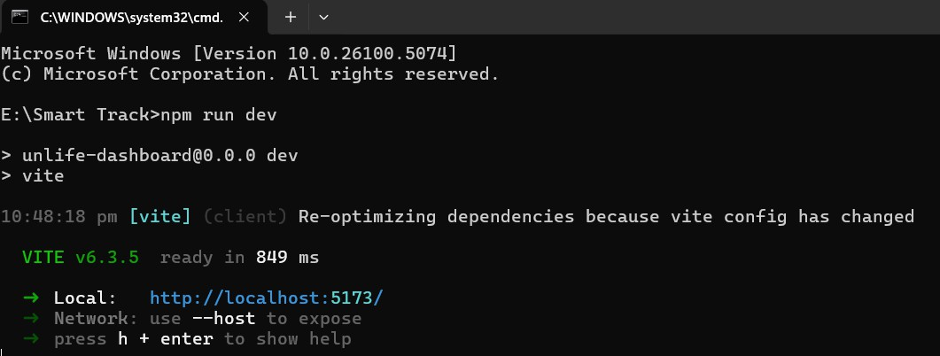
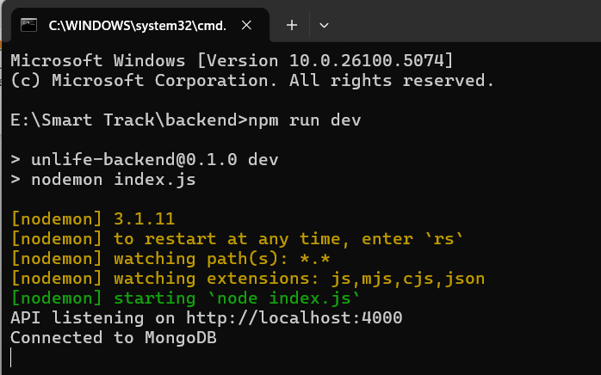
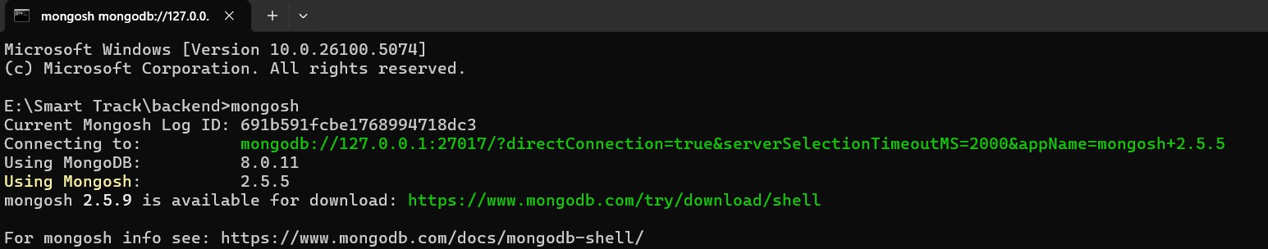

Screen shot 2: Uploading and displaying tasks or notes in a React component or data retrieval from MongoDB in backend.
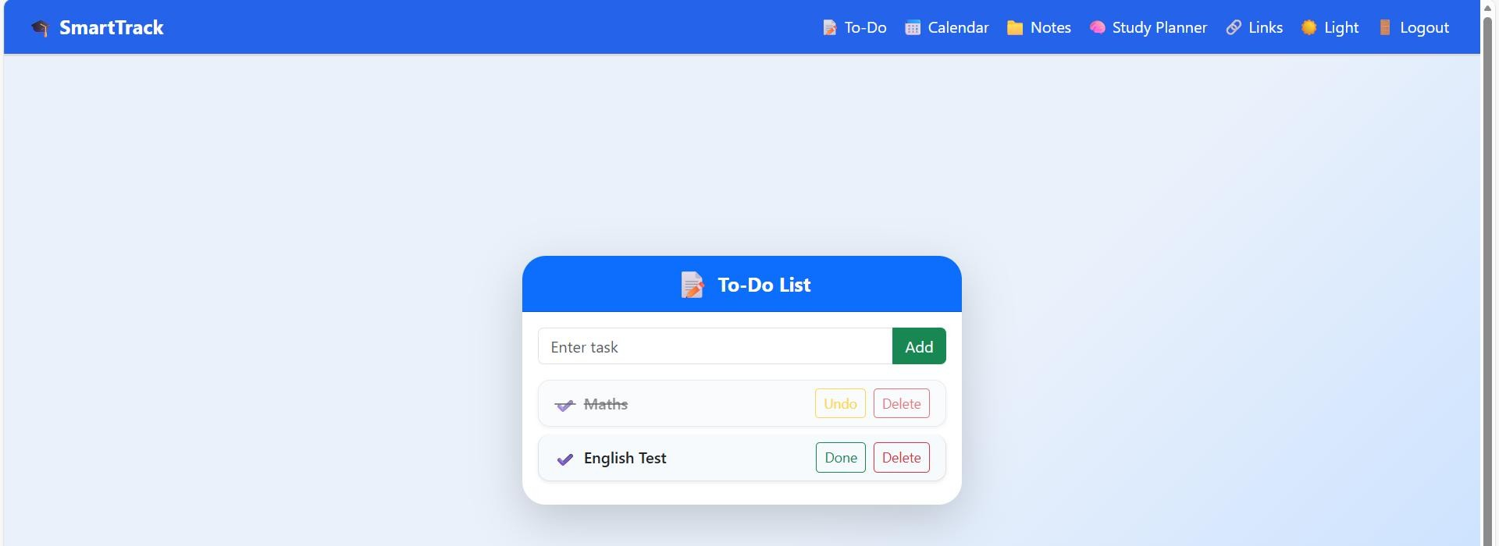
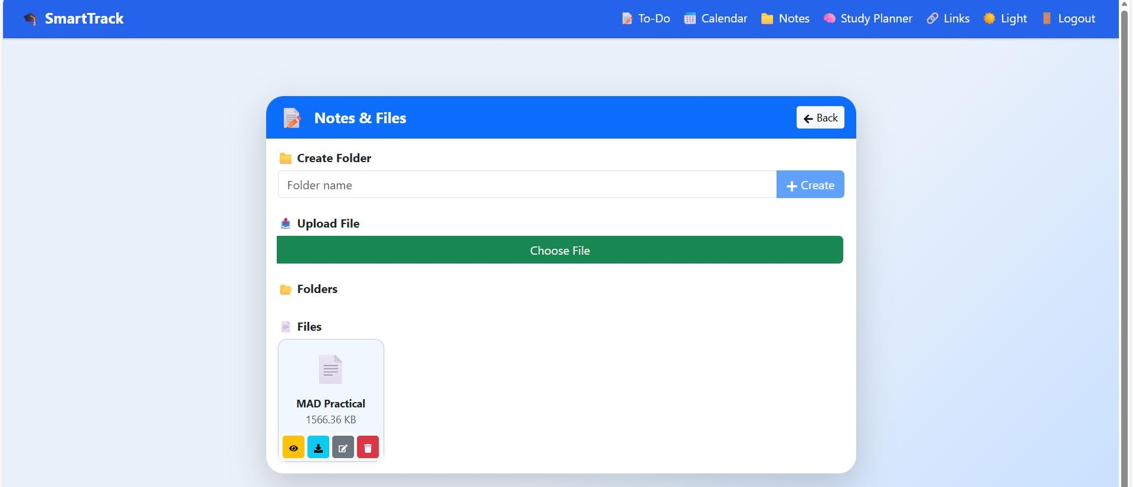
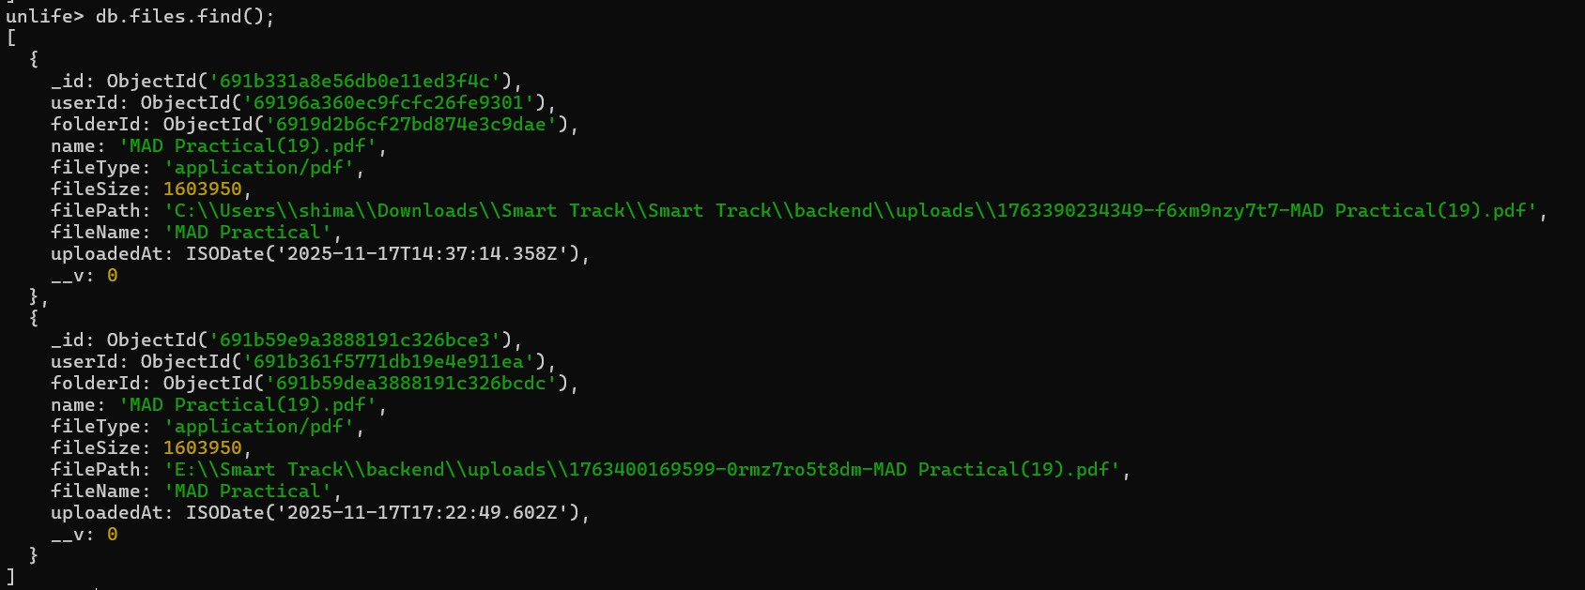

Screen shot 3: Displaying frontend UI screens, e.g., the dashboard home page, task management UI, calendar, notes section, or study planner screen.

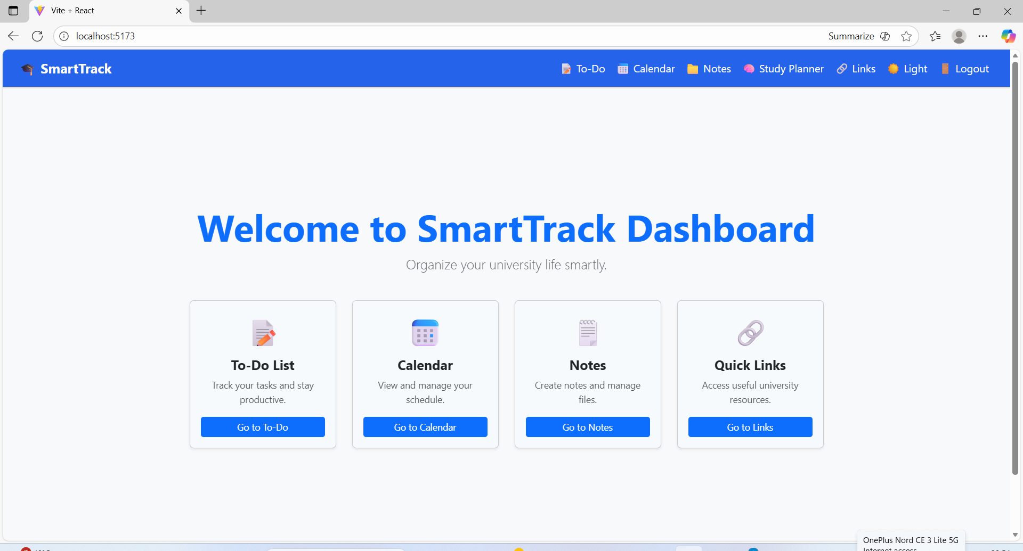
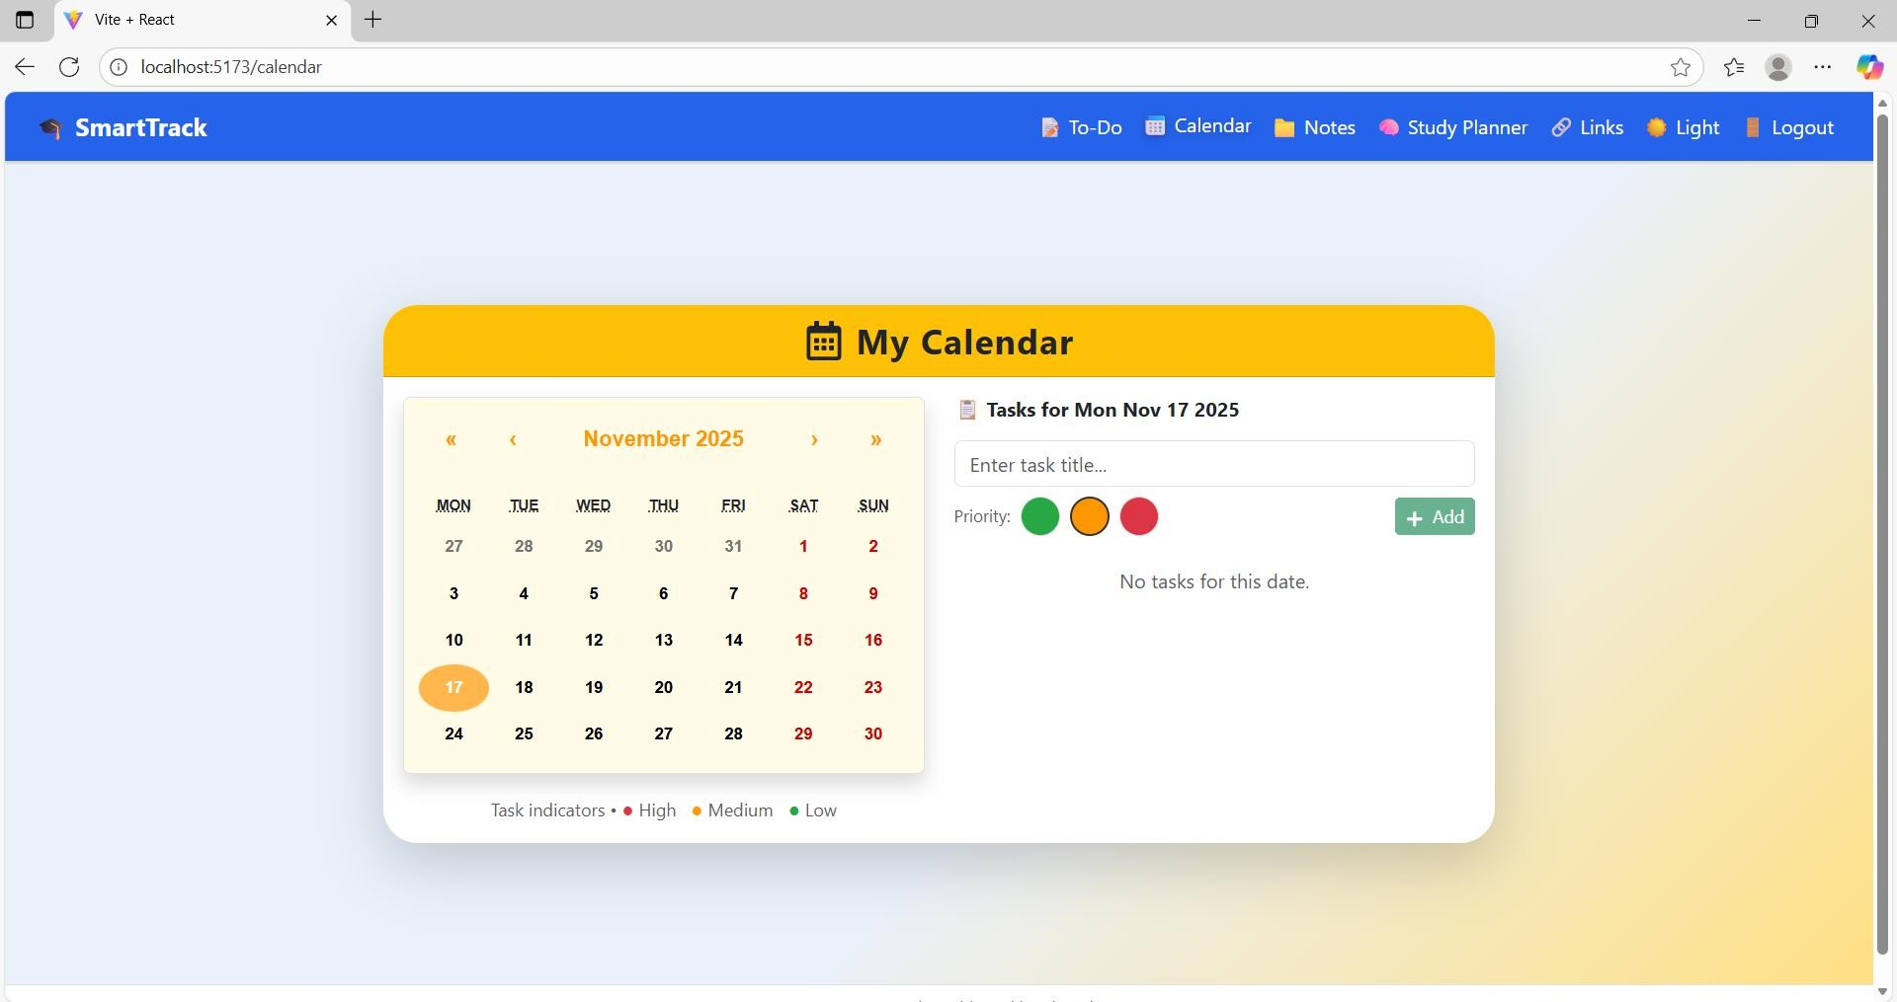

Screen shot 4: – Importing React libraries, hooks (useState, useEffect), and setting up component structure in files like App.jsx, Navbar.jsx, or other components.

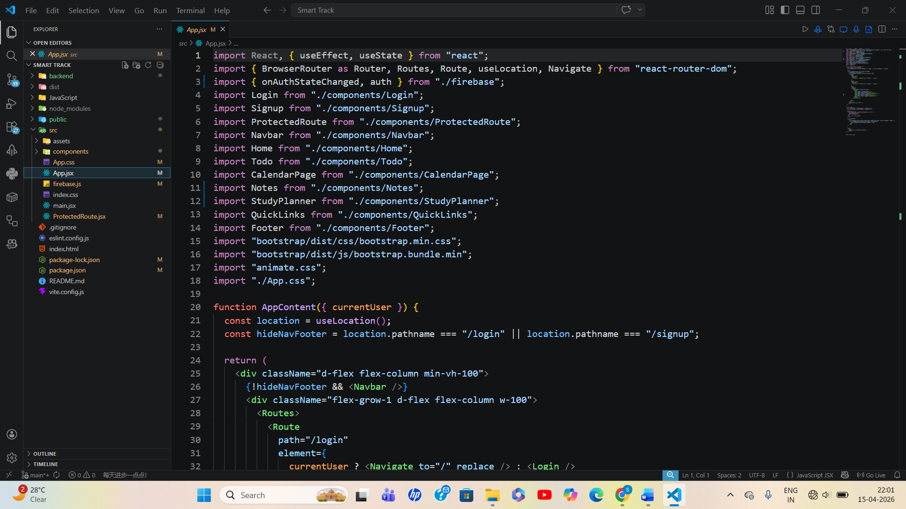

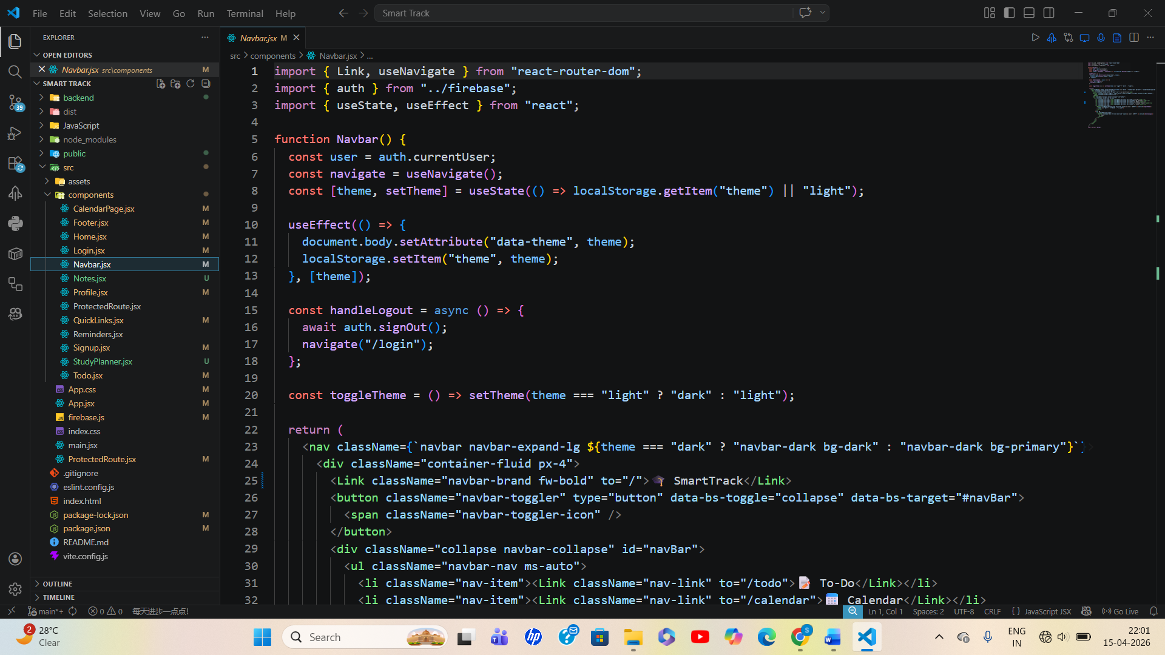

Screen shot 5: – Defining Mongoose schemas and models such as User, Task, StudyPlan, File, and Folder for database structure.

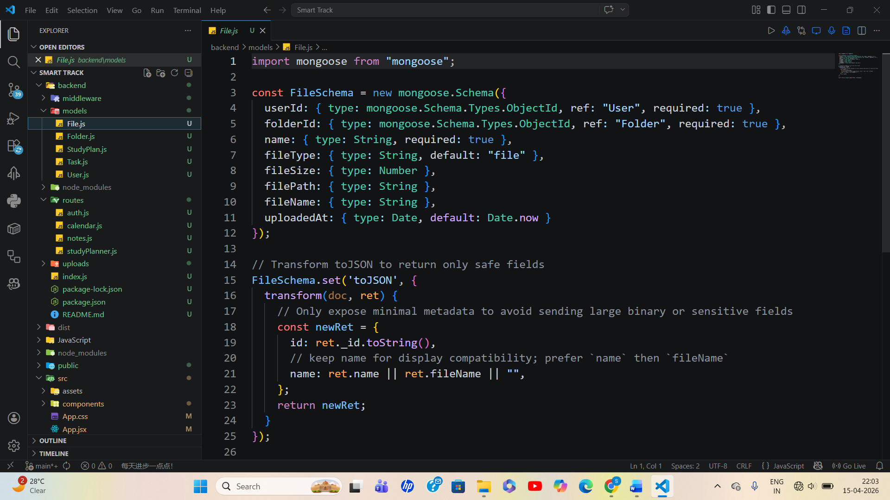

Screen shot 6: – Importing Node.js modules and initializing Express server, middleware setup (CORS, JSON parsing), and environment configuration.

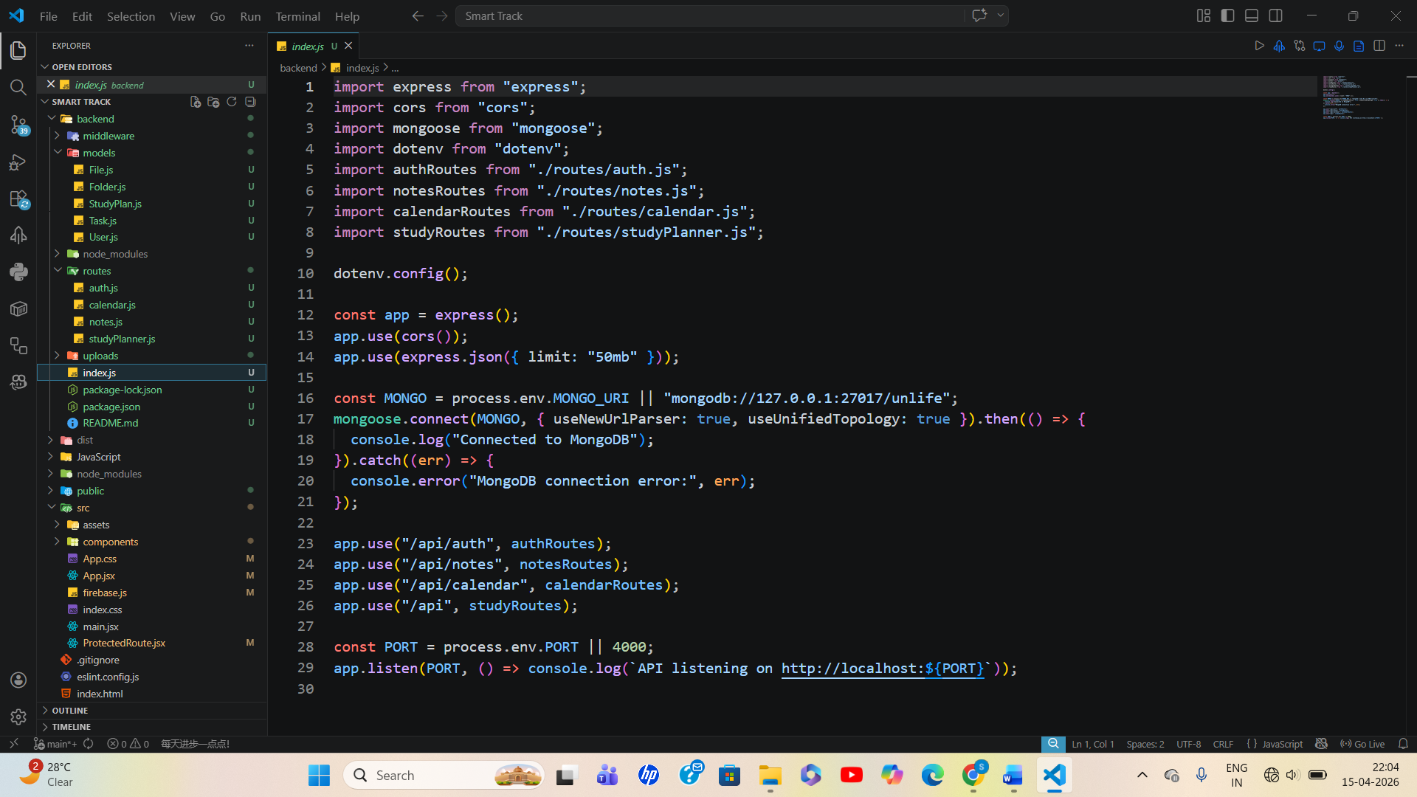

FUTURE SCOPE OF THE PROJECT
The future of SmartTrack Dashboard is promising, with opportunities to enhance productivity and academic management through advanced technologies and feature expansions. Key focus areas include real-time collaboration, AI-driven insights, and broader integration with institutional systems to better serve students and educators.
      - Enhanced Collaboration: Introduce shared task lists, study groups, and real-time chat features to support peer-to-peer academic cooperation.
      - AI-Powered Study Assistance: Use machine learning to provide personalized study recommendations, automated reminders, and progress analysis based on user habits.
      - Cross-Platform Mobile Apps: Develop native Android and iOS applications for on-the-go access with offline support and push notifications.
      - Integration with University Systems: Sync with campus ERP systems, Moodle, and library databases for seamless resource access and automated schedule imports.
      - Improved Data Analytics: Offer educators and administrators dashboards for usage statistics and student engagement insights to support academic planning.
      - Voice and Chatbot Assistance: Implement voice commands and AI chatbots for quick task management, query resolution, and scheduling.
      - Gamification: Add achievement badges, leaderboards, and reward points to motivate consistent study habits and task completion.
      - Flexible Customization: Allow users to tailor modules, themes, and notifications to suit personal workflows and accessibility needs.
      - Enhanced Security and Privacy: Adopt advanced encryption, multi-factor authentication, and compliance with data protection regulations to safeguard user data.
      - Offline and Progressive Web App (PWA) Support: Enable continued functionality when offline with seamless syncing once connectivity is restored.
By focusing on these areas, SmartTrack Dashboard can evolve into a comprehensive academic productivity ecosystem that empowers students, educators, and institutions alike.

KEY INSIGHTS
The SmartTrack Dashboard successfully integrates multiple academic productivity tools into a unified platform, enhancing student organization and efficiency. Early testing shows smooth functionality across task management, calendar scheduling, note-taking, and study planning modules, with responsive UI and secure authentication.
- User Experience and Interaction
  - The intuitive interface encourages consistent use of productivity features.
  - Dark/light theme toggle and toast notifications improve usability.
  - Grouping notes and files into folders helps organize resources logically.
- Data Handling and Security
  - Sensitive data, such as passwords, is protected with bcrypt hashing.
  - JWT authentication effectively manages user sessions with token expiry.
  - File uploads are stored securely on disk with metadata in MongoDB, avoiding database size limits.
- Task and Time Management
  - Prioritizing tasks and marking completion promotes focused study habits.
  - The study planner algorithm allocates time efficiently across subjects based on difficulty and exam schedules.
  - Calendar integration visualizes deadlines and events clearly.
- System Performance and Reliability
  - Combining Vite for frontend builds and Express for RESTful APIs yields performant responsiveness.
  - Robust validation and error handling minimize unexpected crashes or incorrect data entry.
  - Modular backend structure simplifies debugging and future feature expansions.
- Future Enhancement Potential
  - Adding real-time collaboration and AI-based task recommendations could further improve productivity.
  - Mobile app versions and offline capabilities would increase accessibility.
  - Integration with university ERP systems and learning management platforms can centralize academic workflows entirely.
These insights highlight the platform’s practicality in supporting students’ academic success through organized task scheduling, resource management, and personalized study planning.

CONCLUSION

The task of managing academic responsibilities efficiently is challenging for students due to scattered tools and lack of integration. The SmartTrack Dashboard addresses this by providing a centralized platform that combines task management, scheduling, note-taking, and study planning in one accessible web application. The implementation demonstrated the value of standardized data handling, secure authentication, and responsive design in enhancing productivity.
As digital education evolves, platforms like SmartTrack play a vital role in reducing student workload and improving organizational skills. While the system performs well in typical use cases, future improvements such as AI-based recommendations and mobile accessibility can greatly enhance its effectiveness.
Overall, this project highlights the importance of designing user-centric academic tools that simplify study management and foster consistent work habits. By offering a practical, modular, and secure solution, SmartTrack contributes to a more organized and successful academic journey for students. Continuous development, user feedback, and integration with institutional systems will further amplify the benefits of such platforms.

REFERENCES

[1] Roy, S., & Dutta, S. (2022). Designing an integrated student dashboard for academic management and productivity. International Journal of Computer Applications, 184(35), 1-7.
[2] Singh, R., & Kaur, M. (2021). Development of college student productivity web apps using MERN stack. IEEE Xplore, 2021, 318-324.
[3] Student Management System. IJCRT, 2018.
[4] Google Calendar – Popular calendar scheduling app. Website: https://calendar.google.com
[5] MongoDB – NoSQL database used for backend data storage. https://www.mongodb.com
[6] Express.js – Node.js framework for building web services. https://expressjs.com

